30.61: The energy density in the sunspot is 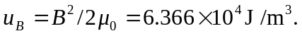
The total energy stored in the sunspot is 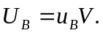
The mass of the material in the sunspot is 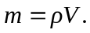
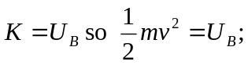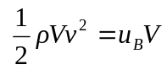
The volume divides out, and 